Lab 9 – Torque and Equilibrium
https://www.youtube.com/watch?v=UPGD3Tb62Zc&list=PLLF2jNBy_OPumuv2eSvIbvnDDfQj0cGEU
All entries should have SI base units with the correct number of digits
Do not do Configuration C
Use g = 9.8 m/s² (exact value, aka infinite sig figs)

Introduction – Theoretical equations
$${\overset{⃑}{τ}}_{net}=\sum{\overset{⃑}{τ}}$$
Condition for rotational equilibrium
$${\overset{⃑}{τ}}_{net}=0$$
$$τ=Fd$$
Unit analysis: $\left[N\right]\left[m\right]=\left[kg\frac{m^{2}}{s^{2}}\right]=[J]$
Use the Newton-meter unit in table entries
Where $d$ is the distance to the lever arm and $F=mg$
Clockwise rotation positive torque
Counterclockwise rotation negative torque

Configuration A:
$$\sum{\overset{⃑}{τ}}=0$$
$${\overset{⃑}{τ}}_{500}+{\overset{⃑}{τ}}_{200}=0$$
$${\left(Fd\right)}_{500}+{(-Fd)}_{200}=0$$

Configuration B:
$$\sum{\overset{⃑}{τ}}=0$$
$${\overset{⃑}{τ}}_{500}+{\overset{⃑}{τ}}_{m}=0$$
$${\left(Fd\right)}_{500}+{(-Fd)}_{m}=0$$
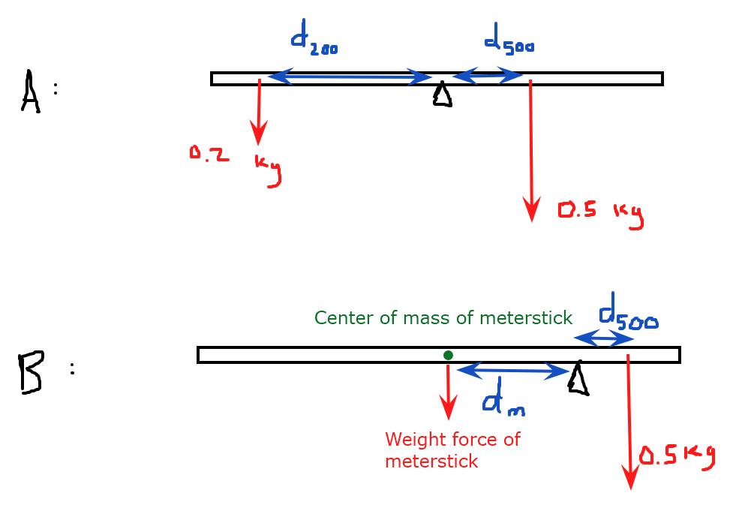
Table 1: Initial Measurements
Mass of meterstick | 136.6 g
Position of meterstick’s center of mass | 50 cm
Total mass of 200 g weight (with clip) | 216.3 g
Total mass of 500 g weight (with clip) | 516.5 g

Configuration A: 500 gram weight between 60 cm and 70 cm position, with a 200 gram counterweight
Table 2: Data from Configuration A
500 gram position | 61.8 cm
200 gram position | 21.9 cm

Configuration B: 500 gram weight between 90 cm and 100 cm position, with meterstick off center
Table 3: Data from Configuration B
500 gram position | 90 cm
Pivot position | 81.7 cm

Table 4: Calculate lever arm data. Show your calculations below the table.
 | Meterstick lever arm | 500 g lever arm | 200 g lever arm
Configuration A | 0 | 3.09NM | 0.4NM
Configuration B | 0.25NM | 0.415 | N/A

Lever arm is the perpendicular distance from the axis of rotation to the line of action of force
It will be fd.
Force for 5oograms= 500/1000*10=5N
TORQUE=5*61.8/100=3.09NM
TORQUE FOR 200=200/1000*10*21.9/1OO=0.4NM
CONFIGURATION B
METER STICK LEVER=136.6/1000*10*0.183=0.25NM
500/1000*10*8.4/100=0.415

Table 5: Calculate torque data. Show your calculations below the table.
 | $${\overset{⃑}{τ}}_{500}$$ | $${\overset{⃑}{τ}}_{200}$$ | $${\overset{⃑}{τ}}_{m}$$
Configuration A | 3.2NM | 0.47 | N/A
Configuration B | 0.43NM | N/A | 0.415

TORQUE= FD
5.16N*0.618=
2.163*0.219=0.4NM
5.16*O.O84=0.43NM
Table 6: Calculate net torque. Show your calculations below the table.
 | Net torque
Configuration A | 2.73NM
Configuration B | O.015NM

NET TORQUE IS THE SUM OF ALL TORQUES IN A CONFIGURATION
THE FORCES ARE EQUAL AND OPPOSITE
3.2-047=2.73
0.43-0.415=

